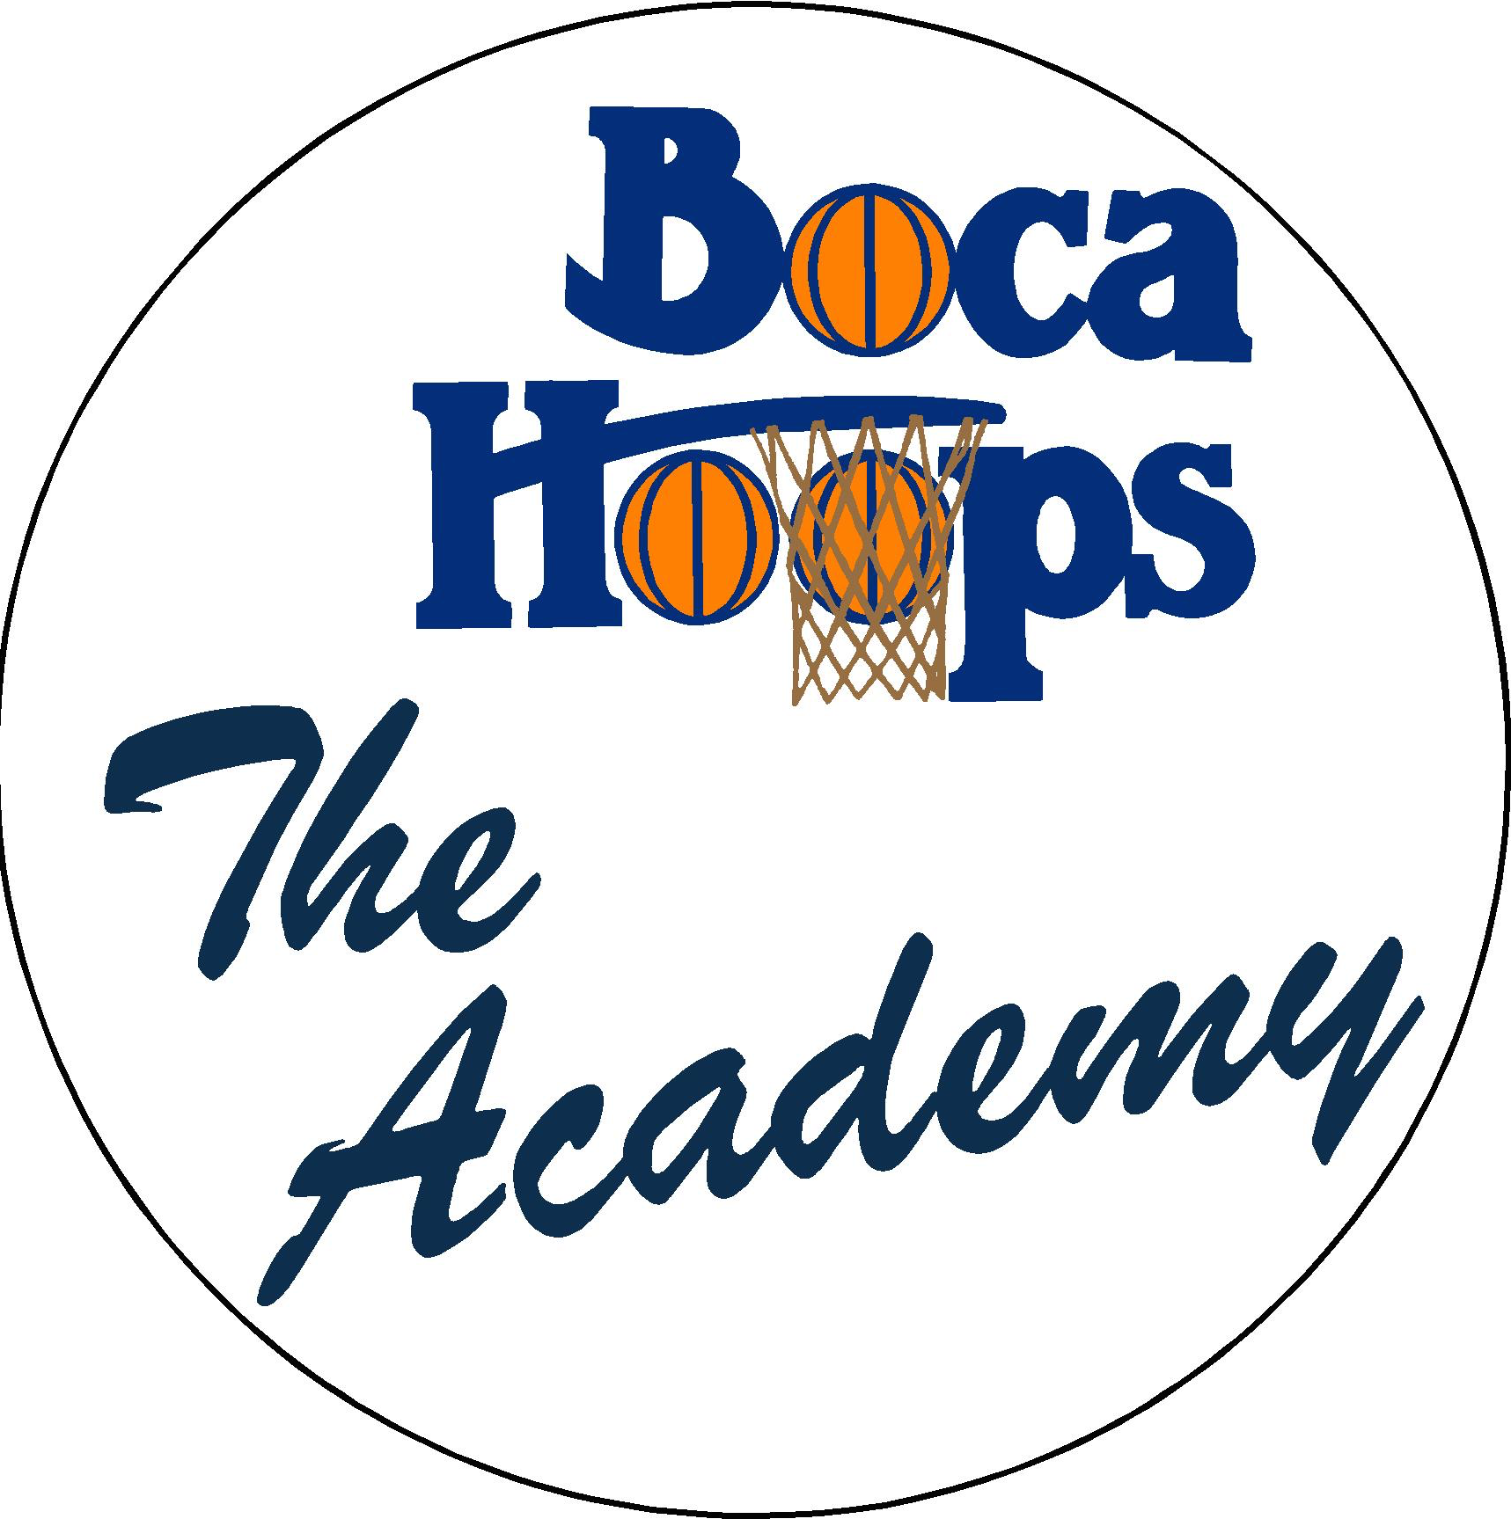

Last Name: ________________________________________________________ First: ________________________________

Address: ________________________________________________________ City __________________ Zip _____________

D.O.B. _________________________________ (M) (F) Grade: _______________________________________________

E mail: ______________________________________________________________________________________________________

Phone Number: ___________________________________________________________________________________________

I do hereby release and forever discharge any and all rights and claims for damages against The Academy faculty, Boca Hoops Inc. and its representatives. Furthermore, I certify that the named applicant is in good health, and is capable of participating in The Academy. I understand that the accident insurance provided is a secondary coverage with a deductible.

Signature of parent/guardian: _________________________________________ Date: _________
Academy Clinics

Site: Lynn University Gym

Head Instructor: Jeff Price, Men’s Varsity Coach
Lynn University
Staff: Coach Price’s Coaching Staff & Players

Site: Boca Raton Middle School Gym

Head Instructor: Matt Ryder, Boys Varsity Coach
Olympic Heights High School
Staff: Coach Ryder’s Coaching Staff & Players

Ages 7-12 Boys and Girls (as of September 1st):

Fee: $25.00 for 1.5 hour Session
(Start Time 1 PM)

CLINIC #1: _____________ September 10: Boca Raton Middle School

CLINIC #2: _____________ September 17: Lynn University

CLINIC #3: _____________ September 24: Lynn University

CLINIC #4: ____________ October 1: Boca Raton Middle School

CLINIC #5: ____________ October 8: Lynn University

Total Paid: ___________________ (cash) __________ (check #) _______________
Checks payable to: Boca Hoops, Inc.

Mail in: Boca Hoops – The Academy
PO Box 6068
Boca Raton, Florida 33427

Information or questions: info@bocahoops.com
Attention: The Academy

